ReactJS Hands-on 15 - React Forms (Ticket Raising App)

Commands Used
- npx create-react-app ticketraisingapp
- cd ticketraisingapp
- npm start

Project Structure

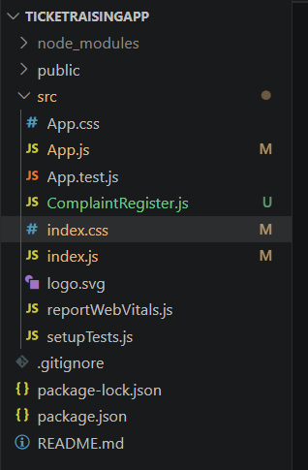

App.js
import ComplaintRegister from './ComplaintRegister';
function App(){
return <ComplaintRegister/>;
}
export default App;

ComplaintRegister.js
import React,{Component} from 'react';
class ComplaintRegister extends Component{
constructor(props){
super(props);
this.state={ename:'',complaint:'',referenceNumber:Math.floor(Math.random()*100)+1};
}
handleChange=(e)=>{this.setState({[e.target.name]:e.target.value});}
handleSubmit=(e)=>{
alert('Thanks '+this.state.ename+'\nYour Complaint was Submitted.\nReference ID is: '+this.state.referenceNumber);
e.preventDefault();
}
render(){
return(
<div style={{textAlign:'center',marginTop:'50px'}}>
<h1 style={{color:'red'}}>Register your complaints here!!!</h1>
<form onSubmit={this.handleSubmit}>
<table style={{margin:'auto'}}><tbody>
<tr><td>Name:</td><td><input type='text' name='ename' value={this.state.ename} onChange={this.handleChange}/></td></tr>
<tr><td>Complaint:</td><td><textarea rows='4' cols='20' name='complaint' value={this.state.complaint} onChange={this.handleChange}></textarea></td></tr>
<tr><td></td><td><button type='submit'>Submit</button></td></tr>
</tbody></table>
</form>
</div>
);
}
}
export default ComplaintRegister;

index.js
import React from 'react';
import ReactDOM from 'react-dom/client';
import './index.css';
import App from './App';
const root=ReactDOM.createRoot(document.getElementById('root'));
root.render(<React.StrictMode><App/></React.StrictMode>);

index.css
body{font-family:Arial;}
input,textarea{padding:5px;margin:5px;}
button{padding:6px 15px;cursor:pointer;}

Output
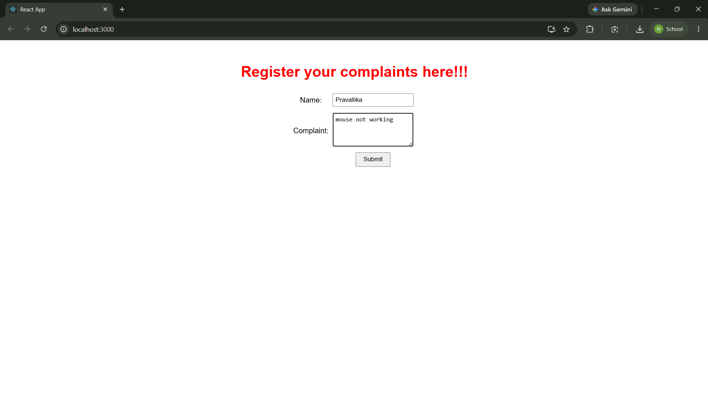
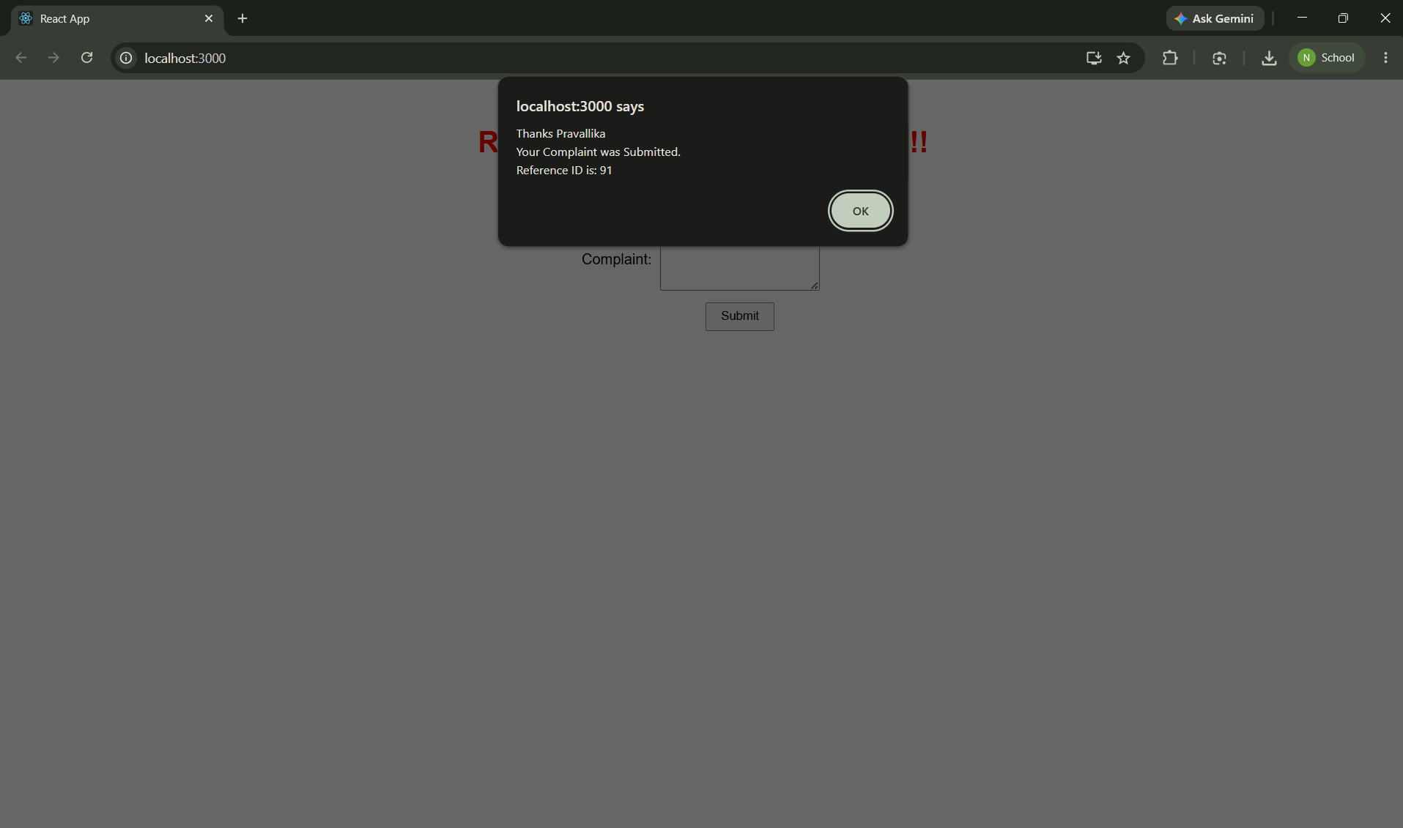

Conclusion
The application successfully demonstrates React Forms, controlled components, handling input controls, and form submission using handleSubmit.

